Assignment -1

# Python Programming

|  |  |
| --- | --- |
| Assignment Date | 19 November 2022 |
| Student Name | C.Rosy |
| Student Roll Number | 820519106033 |
| Maximum Marks | 2 Marks |

**BASIC PYTHON**

## Question-1:

Split this string

s = "Hi there Sam!"

## Solution:

s**.**split()

['Hi', 'there', 'Sam!']

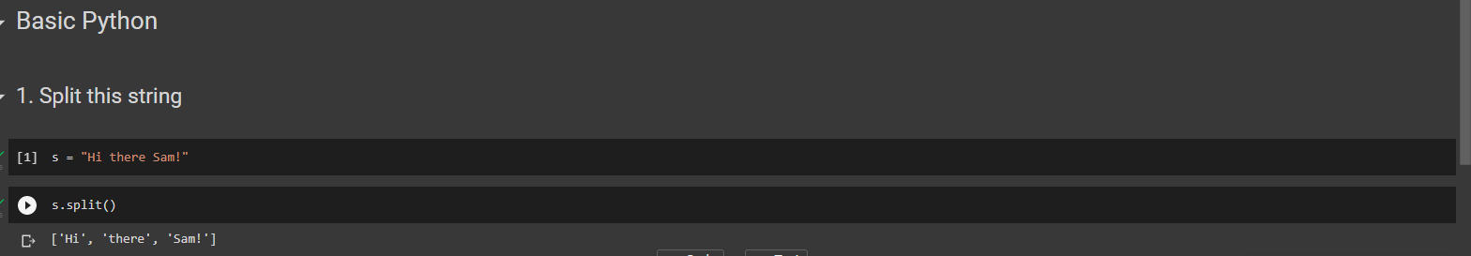

## Question-2:

Use .format() to print the following string.

Output should be: The diameter of Earth is 12742 kilometers. planet = "Earth"

diameter = 12742

## Solution:

a**=**"The diameter of {} is {} kilometers"**.**format(planet,diameter) print(a)

The diameter of Earth is 12742 kilometers

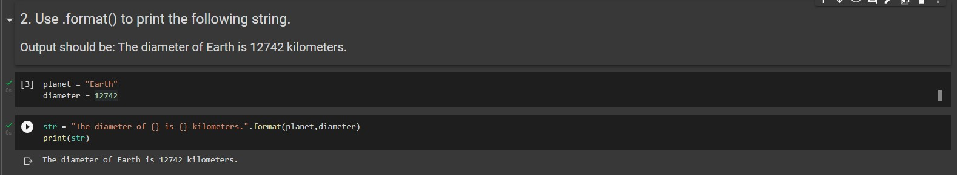

## Question-3:

In this nest dictionary grab the word "hello"

d = {'k1':[1,2,3,{'tricky':['oh','man','inception',{'target':[1,2,3,'hello']}]}]}

## Solution:

print(d['k1'][3]["tricky"][3]['target'][3]) hello

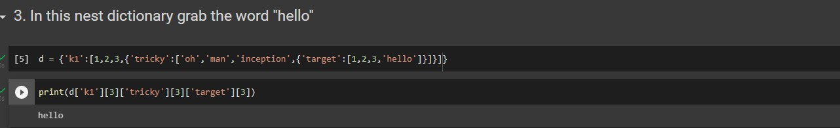

# NUMPY

**import** numpy **as** np

## Question-4:

1. Create an array of 10 zeros?

## Solution:

np**.**zeros(10)

array([0., 0., 0., 0., 0., 0., 0., 0., 0., 0.])

1. Create an array of 10 fives?

## Solution:

np**.**ones(10)**\***5

array([5., 5., 5., 5., 5., 5., 5., 5., 5., 5.])

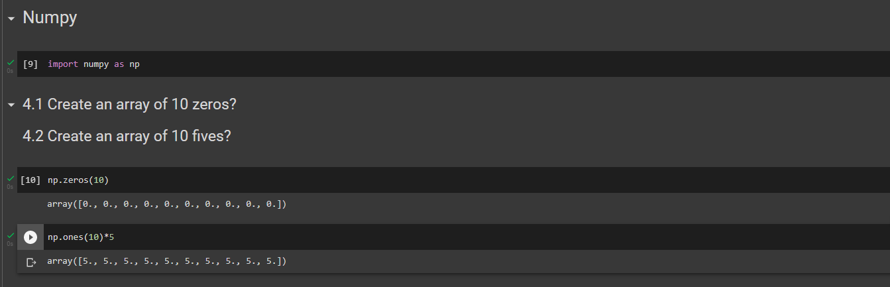

## Question-5:

Create an array of all the even integers from 20 to 35

## Solution:

np**.**arange(20,35,2)

array([20, 22, 24, 26, 28, 30, 32, 34])

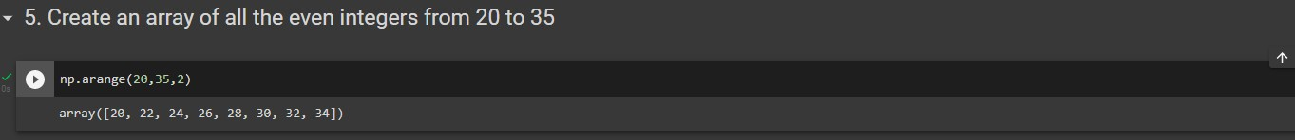

## Question-6:

Create a 3x3 matrix with values ranging from 0 to 8

## Solution:

np**.**array([[0,1,2],[3,4,5],[6,7,8]])

array([[0, 1, 2],

[3, 4, 5],

[6, 7, 8]])

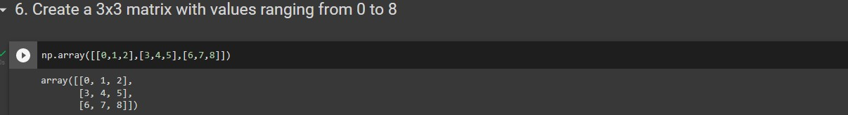

## Question-7:

Concatenate a and b

a = np.array([1, 2, 3]), b = np.array([4, 5, 6])

## Solution:

a**=**np**.**array([1,2,3])

b**=**np**.**array([4,5,6]) np**.**concatenate((a,b))

array([1, 2, 3, 4, 5, 6])

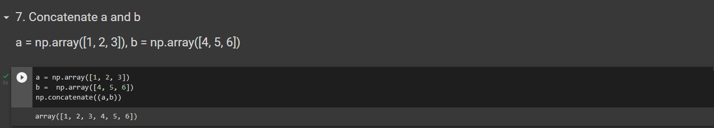

# PANDAS

## Question-8:

Create a dataframe with 3 rows and 2 columns import pandas as pd

## Solution:

data **=** {

"calories": [420, 380, 390],

"duration": [50, 40, 45]

}

*#load data into a DataFrame object:*

df **=** pd**.**DataFrame(data) print(df)

calories duration

|  |  |  |
| --- | --- | --- |
| 0 | 420 | 50 |
| 1 | 380 | 40 |
| 2 | 390 | 45 |

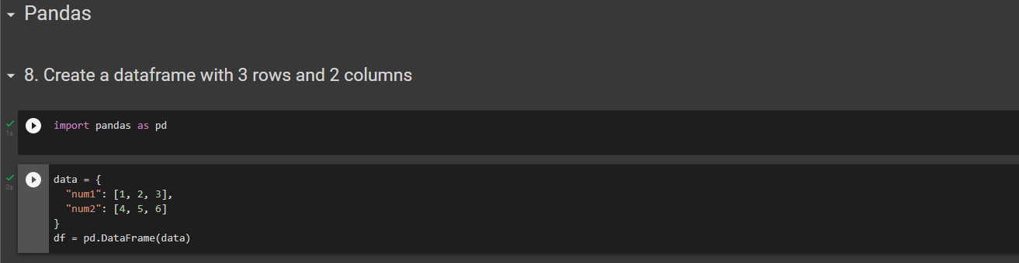

## Question-9:

Generate the series of dates from 1st Jan, 2023 to 10th Feb, 2023

## Solution:

pd**.**date_range(start**=**'1/1/2023',end**=**'2/10/2023')

DatetimeIndex(['2023-01-01', '2023-01-02', '2023-01-03', '2023-01-04',

'2023-01-05', '2023-01-06', '2023-01-07', '2023-01-08',

'2023-01-09', '2023-01-10', '2023-01-11', '2023-01-12',

'2023-01-13', '2023-01-14', '2023-01-15', '2023-01-16',

'2023-01-17', '2023-01-18', '2023-01-19', '2023-01-20',

'2023-01-21', '2023-01-22', '2023-01-23', '2023-01-24',

'2023-01-25', '2023-01-26', '2023-01-27', '2023-01-28',

'2023-01-29', '2023-01-30', '2023-01-31', '2023-02-01',

'2023-02-02', '2023-02-03', '2023-02-04', '2023-02-05',

'2023-02-06', '2023-02-07', '2023-02-08', '2023-02-09',

'2023-02-10'],

dtype='datetime64[ns]', freq='D')

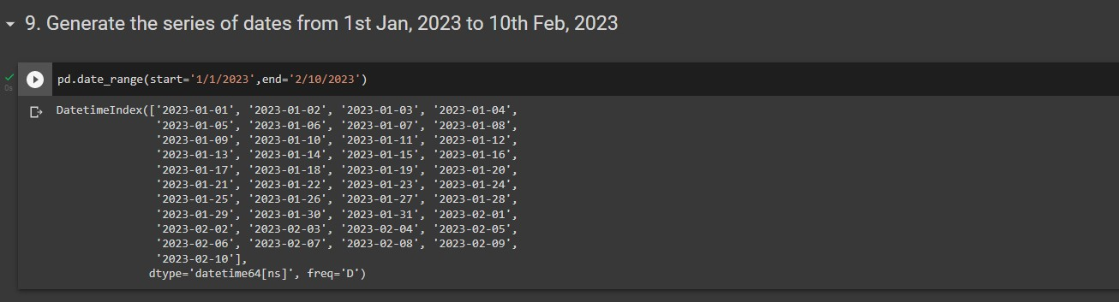

## Question-10:

Create 2D list to DataFrame

lists = [[1, 'aaa', 22], [2, 'bbb', 25], [3, 'ccc', 24]]

lists = [[1, 'aaa', 22], [2, 'bbb', 25], [3, 'ccc', 24]]

## Solution:

pd**.**DataFrame(lists)

|  |  |  |  |
| --- | --- | --- | --- |
|  | **0** | **1** | **2** |
| **0** | 1 | aaa | 22 |
| **1** | 2 | bbb | 25 |
| **2** | 3 | ccc | 24 |

